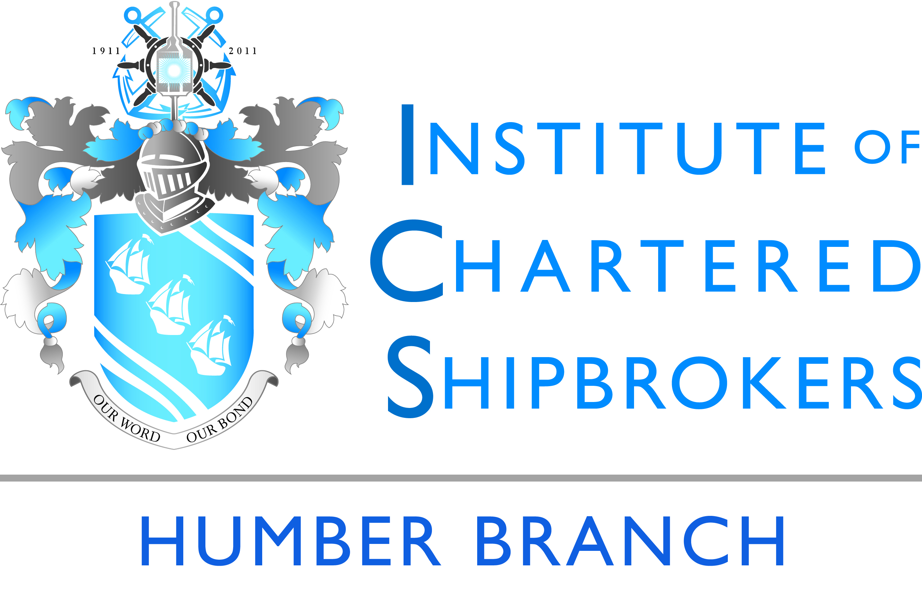 | The Institute of Chartered Shipbrokers, Humber Branch presents:  Humber Branch Annual Dinner 2023  DoubleTree by Hilton Hull, Ferensway, Kingston upon Hull, HU2 8NH  Thursday 2nd March 2023
We are delighted to invite you to
the Institute of Chartered Shipbrokers Humber Branch 2023 Annual Dinner.

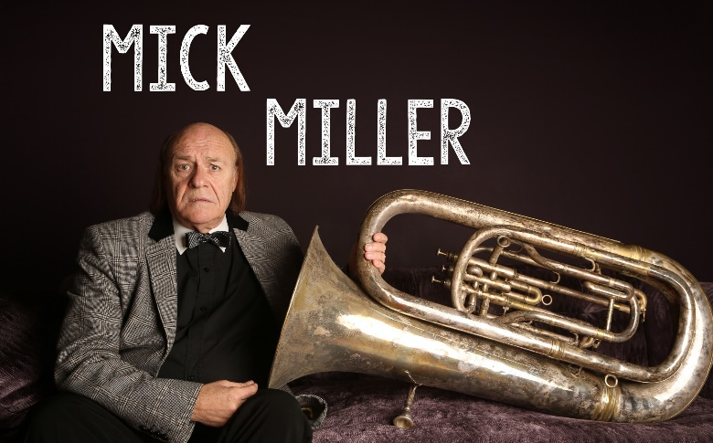 |  |  |  |  |  |  | This year After Dinner Speaker will be Mick Miller. Mick has had a long and successful career stretching over 40 years.  He first came to prominence on the iconic ITV show The Comedians along with great British TV favourites Walker and Boardman. He also made guest appearances on 3, 2, 1, Seaside Special, and Blankety Blank (with his good friend Les Dawson). Live theatre tours and summer season shows followed. He is one of the finest after-dinner speakers you’re ever likely to hear!
Dress code: Dinner jackets for gentlemen
This year’s ticket price will be £65.00 each inclusive of V.A.T. but exclusive of wines.
We look forward to receiving your application for tickets as soon as possible, and please no later than 17th February 2023 together with your bank remittance to the following account:
Sort Code: 16-22-11 | Account Number: 11733887 | Bank: Royal Bank of Scotland PLC
No provisional or faxed applications for tickets will be accepted.
Tickets will be issued only after the booking closing date.
We have negotiated a preferential rate for you.
To book your stay at the DoubleTree by Hilton Hull,
please proceed by using the link available < here >
To: Chairman (Humber Branch): Nick Allen F.I.C.S.
The Institute of Chartered Shipbrokers, Humber Branch Annual Dinner 2023
Ticket Application Form
Please send to me number |  | __________ |  |  | tickets for the above function
Please find my remittance for |  | __________ |  |  | attached (No. tickets at £65.00 per head)
Your Name
Company
Email |  |  |  |  |  | Telephone
Dietary Requirements
Ticket Delivery Address
Signature |  |  |  |  |  | Date
Please complete this form and return to: Nick Allen FICS at nick.allen@rix.co.uk

